**DATA VISULAZATION – PowerBI**

Power BI is a powerful business analytics tool developed by Microsoft that allows users to visualize and analyze data with greater speed, efficiency, and understanding. It offers a range of features, including data modeling, data transformation, and interactive visualizations. Power BI connects to multiple data sources, providing a comprehensive view of critical business metrics in real-time (BI-Business Intelligence).

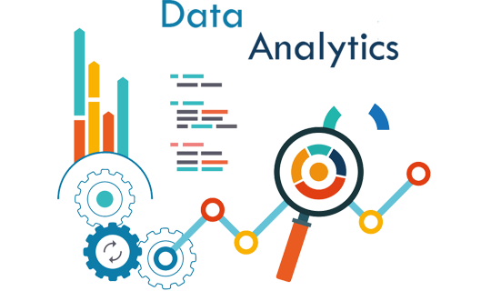



**How PowerBI and DataAnalytics is important?**

In today’s data-driven world, businesses generate and have access to vast amounts of data. However, data in its raw form is often challenging to interpret and use effectively. Power BI and data visualization address this challenge by converting raw data into actionable insights. For example, a Call Center can use Power BI to visualize key performance indicators like call volumes, average handling times, and customer satisfaction scores. This enables managers to identify areas of improvement, monitor agent performance, and ultimately enhance the customer experience. Similarly, organizations focusing on diversity and inclusion can leverage Power BI to track metrics related to hiring, promotion, and employee turnover. Visualizing this data helps in understanding the current state, identifying gaps, and formulating strategies to foster a more inclusive workplace.

**TASKS EXPLANATION:**

Here is the explanation of the tasks given to me in the course named Power BI Job Simulation offered by pwc

**Task 1: Introduction to PowerBI**

**Task 2: Call Center Dashboard in Power BI**

Creating a comprehensive dashboard in Power BI for a Call Center can significantly improve visibility into key performance indicators (KPIs) and overall performance. For Claire, this dashboard will highlight crucial metrics that can help drive decisions and improvements within the Call Center.

**Dashboard Design:**

The dashboard can be divided into several sections, each focusing on a specific KPI:

**Customer Satisfaction:** A gauge chart showing overall customer satisfaction score.

**Calls Answered vs. Abandoned:** A bar chart comparing answered and abandoned calls.

**Calls by Time:** A line chart displaying call volume trends over selected time periods.

**Average Speed of Answer:** A KPI card showing the average speed of answer.

**Agent’s Performance Quadrant:** A scatter plot visualizing agents based on their average handle time vs. calls answered, with quadrants indicating different performance levels.

By integrating these KPIs into a single dashboard, Claire can easily monitor and analyze Call Center performance, identify areas needing improvement, and make data-driven decisions.

Here is my Dashboard design:

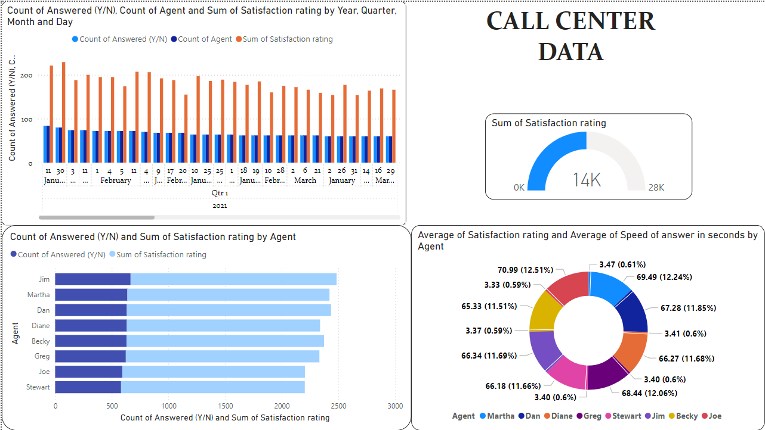

**Task 2: Churn Dashboard Retention Manager**

Creating a dashboard for the retention manager using a churn dataset involves identifying key KPIs that reflect membership engagement and retention.

**Key Performance Indicators (KPIs)**

**Membership Growth Rate:** Track the percentage increase or decrease in membership.

**Attendance Rate:** Measure the average attendance rate for services and events.

**Churn Rate:** Calculate the percentage of members who leave the church.

**Engagement Level:** Assess the participation rate in church activities and groups.

**New Member Rate:** Track the number of new members joining the church.

**Dashboard Design:**

**Membership Growth:** A line chart showing membership growth over time.

**Attendance Rate:** A bar chart displaying average attendance rates.

**Churn Rate:** A KPI card with the churn rate percentage.

**Engagement Level:** A heat map indicating participation rates in various activities.

**New Member Rate:** A pie chart showing the proportion of new members.

The task continuation was to write an Email,

Email to Retention Manager:

Subject: Insights and Recommendations from the Church Dashboard

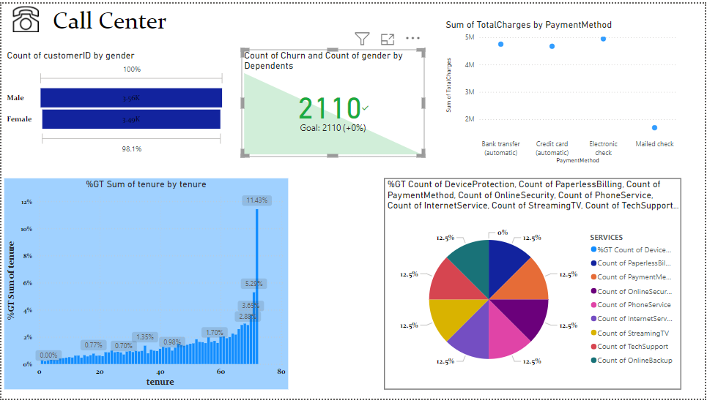 Here is my design on the dashboard

**Task 3: Diversity and Inclusion Dashboard for Telecom Client**

Diversity and inclusion are critical for the success of any organization. Despite efforts to improve gender balance at the executive management level, progress can be slow. This dashboard will help our telecom client identify and address key issues.

**Key Performance Indicators (KPIs):**

**Number of Men and Women:** Track the gender composition at various levels.

**Number of Leavers:** Measure the turnover rate.

**Percentage of Employees Promoted (FY21):** Track overall promotion rates.

**Percentage of Women Promoted:** Measure the promotion rate among female employees.

**Percentage of Hires Men/Women:** Track the gender composition of new hires.

**Turnover Rate:** Calculate the overall turnover rate.

**Average Performance Rating (Men/Women):** Compare performance ratings by gender.

**Dashboard Design:**

**Gender Composition:** A pie chart showing the number of men and women.

**Turnover Rate:** A line chart tracking the turnover rate over time.

**Promotion Rates:** Bar charts comparing overall and gender-specific promotion rates.

**Hiring Trends:** A stacked bar chart showing the gender composition of new hires.

**Performance Ratings:** A side-by-side box plot comparing performance ratings by gender.

Here is my Dashboard design and it contains a turnover page

Conclusion

To make meaningful progress, our telecom client needs to implement a comprehensive strategy that includes raising awareness, providing education, and using data-driven insights to guide their efforts.